1. Data source

Table1: US Cities populations.csv

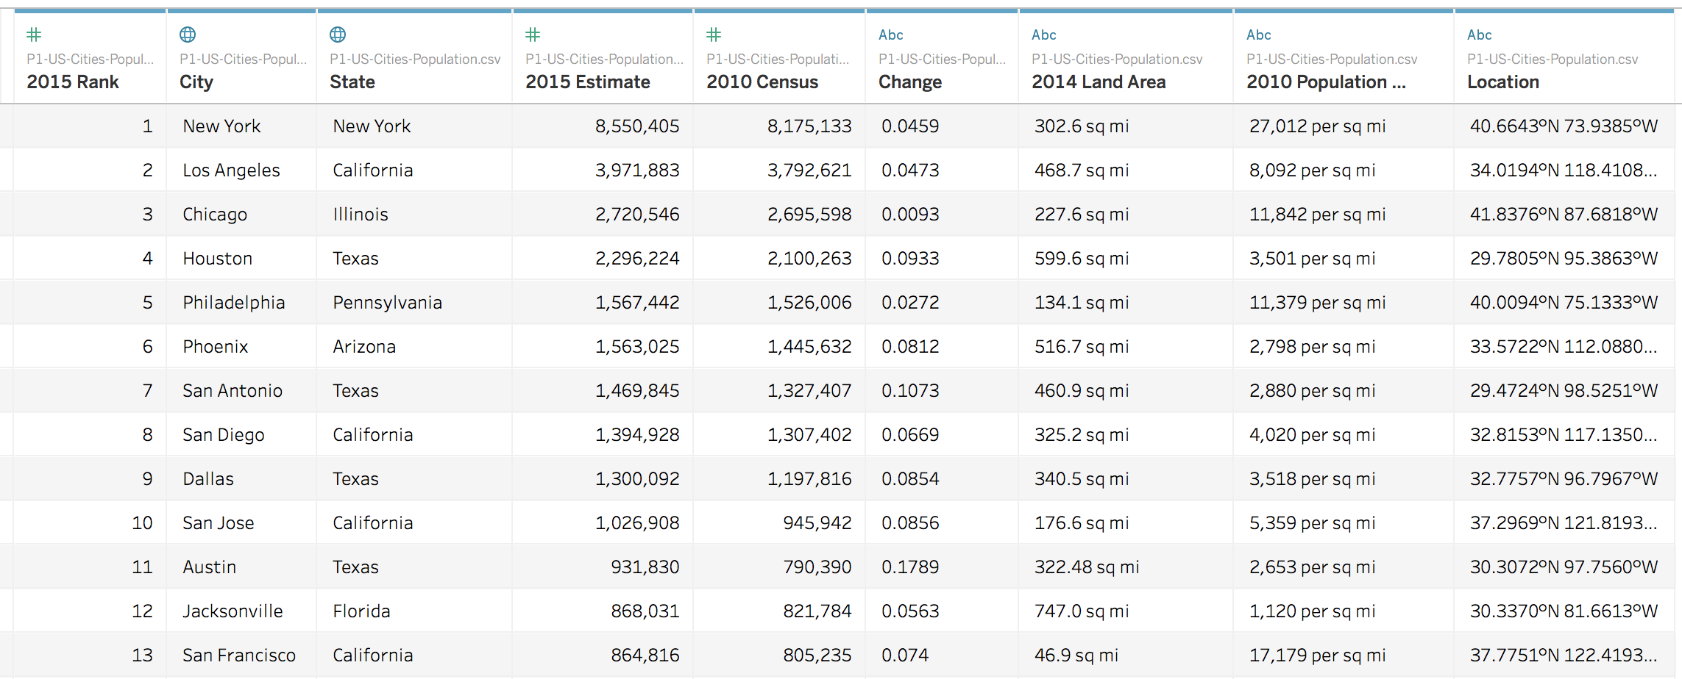

Table2: Startup Expansion.xlsx

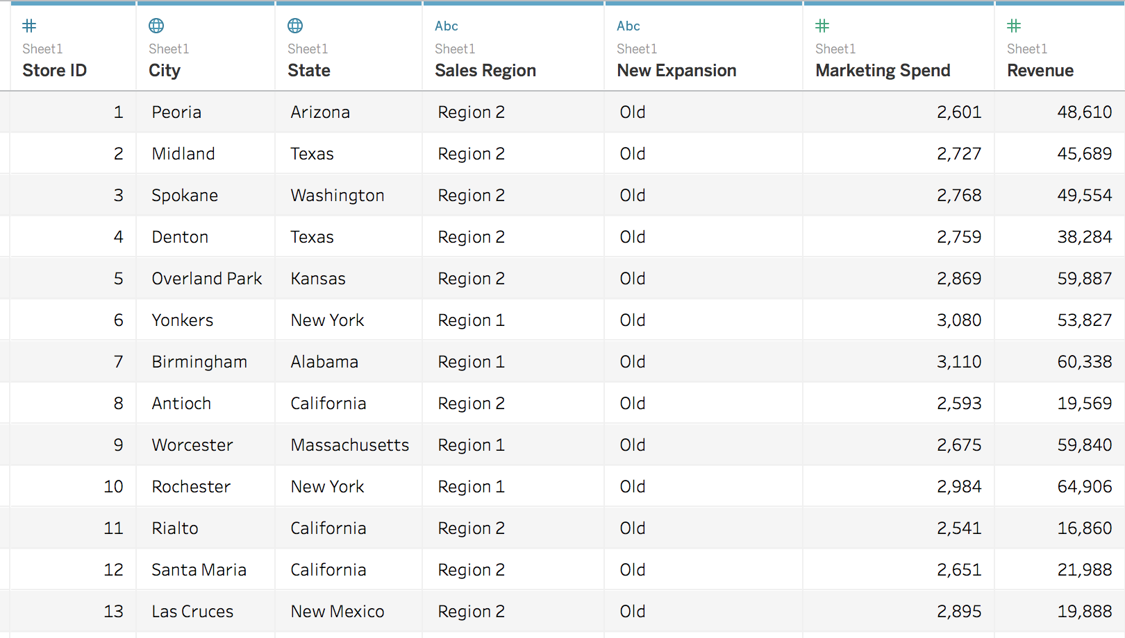

* 1. Revenue Per City Group By State

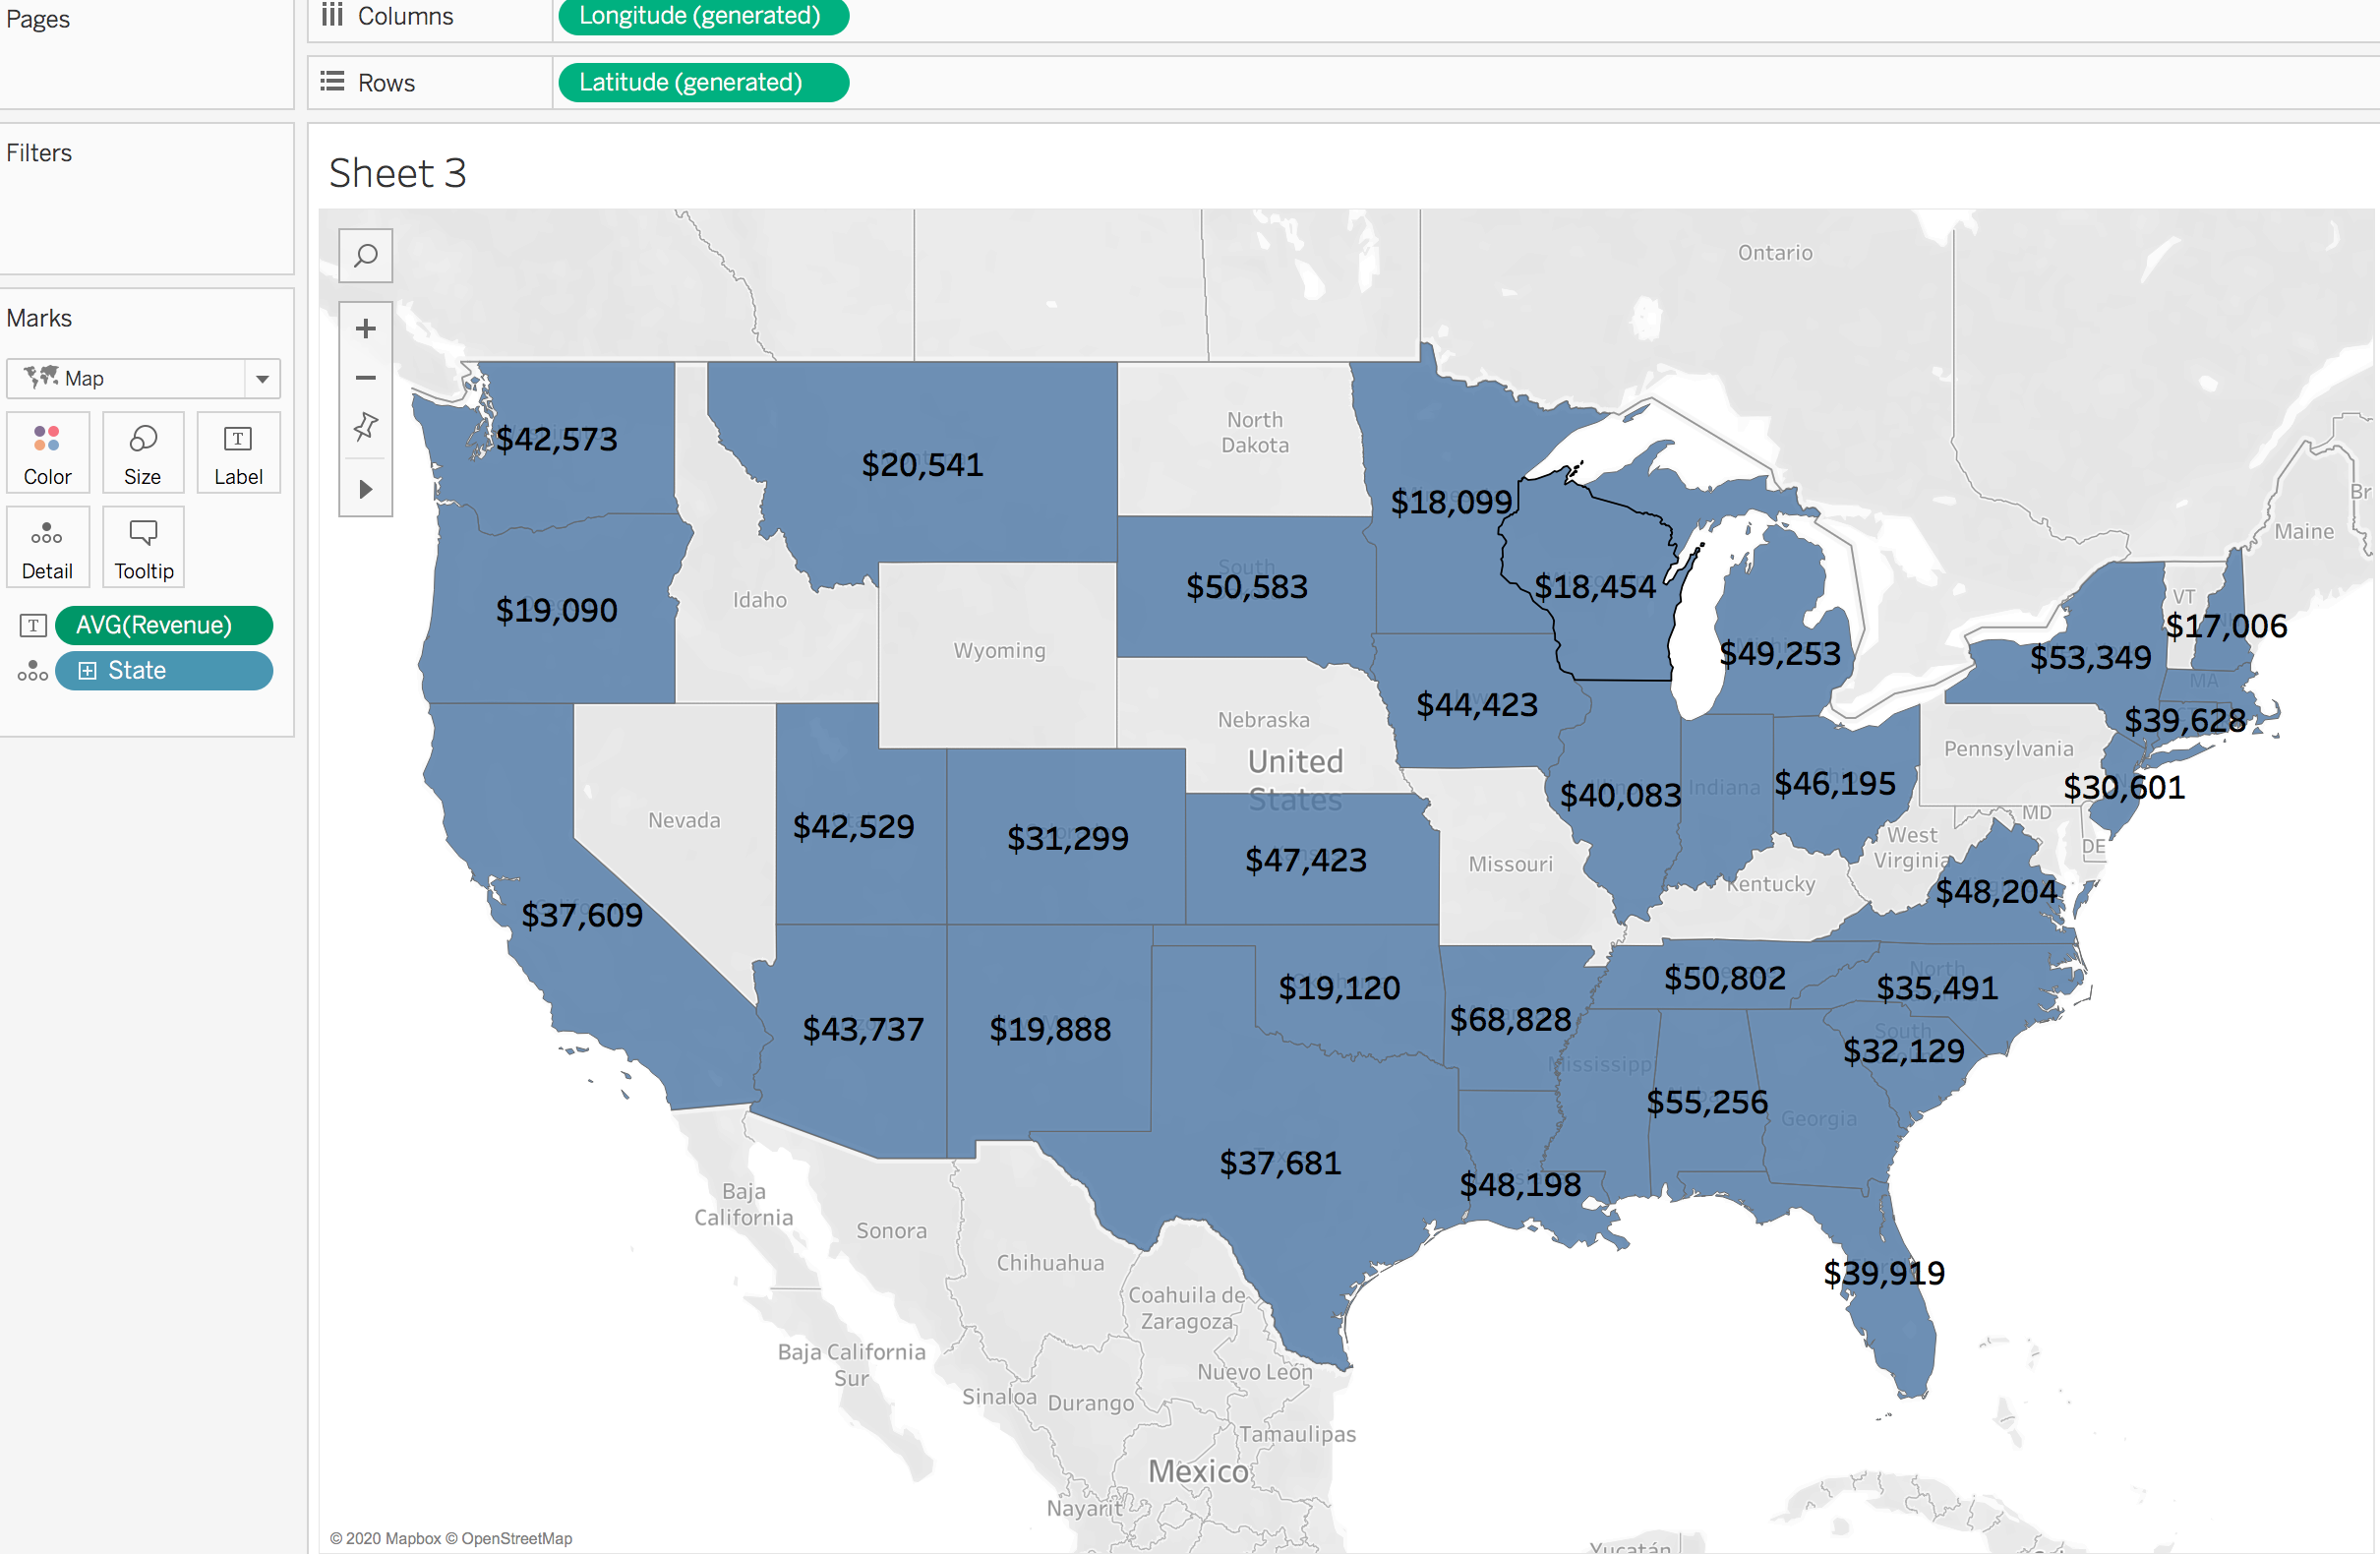

* 1. Avg Marketing Spend Per City Group by State

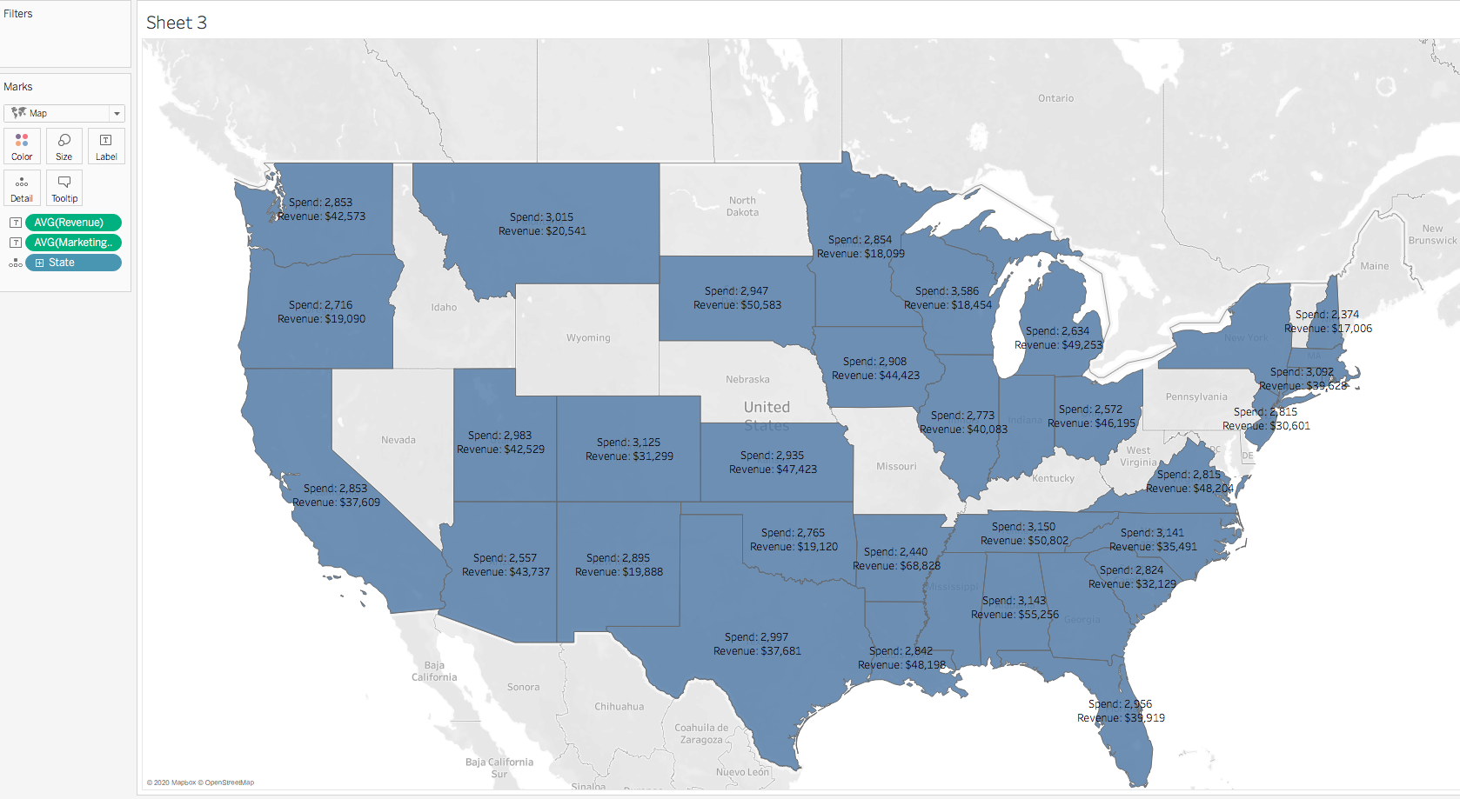

* 1. ROMI Per City Group by State

Create calculated filed *Return On Marketing investment(ROMI)* by:

***[Revenue]/ [Marketing Spend]***

Add calculated filed ROMI into the map, and change the measure method into AVG

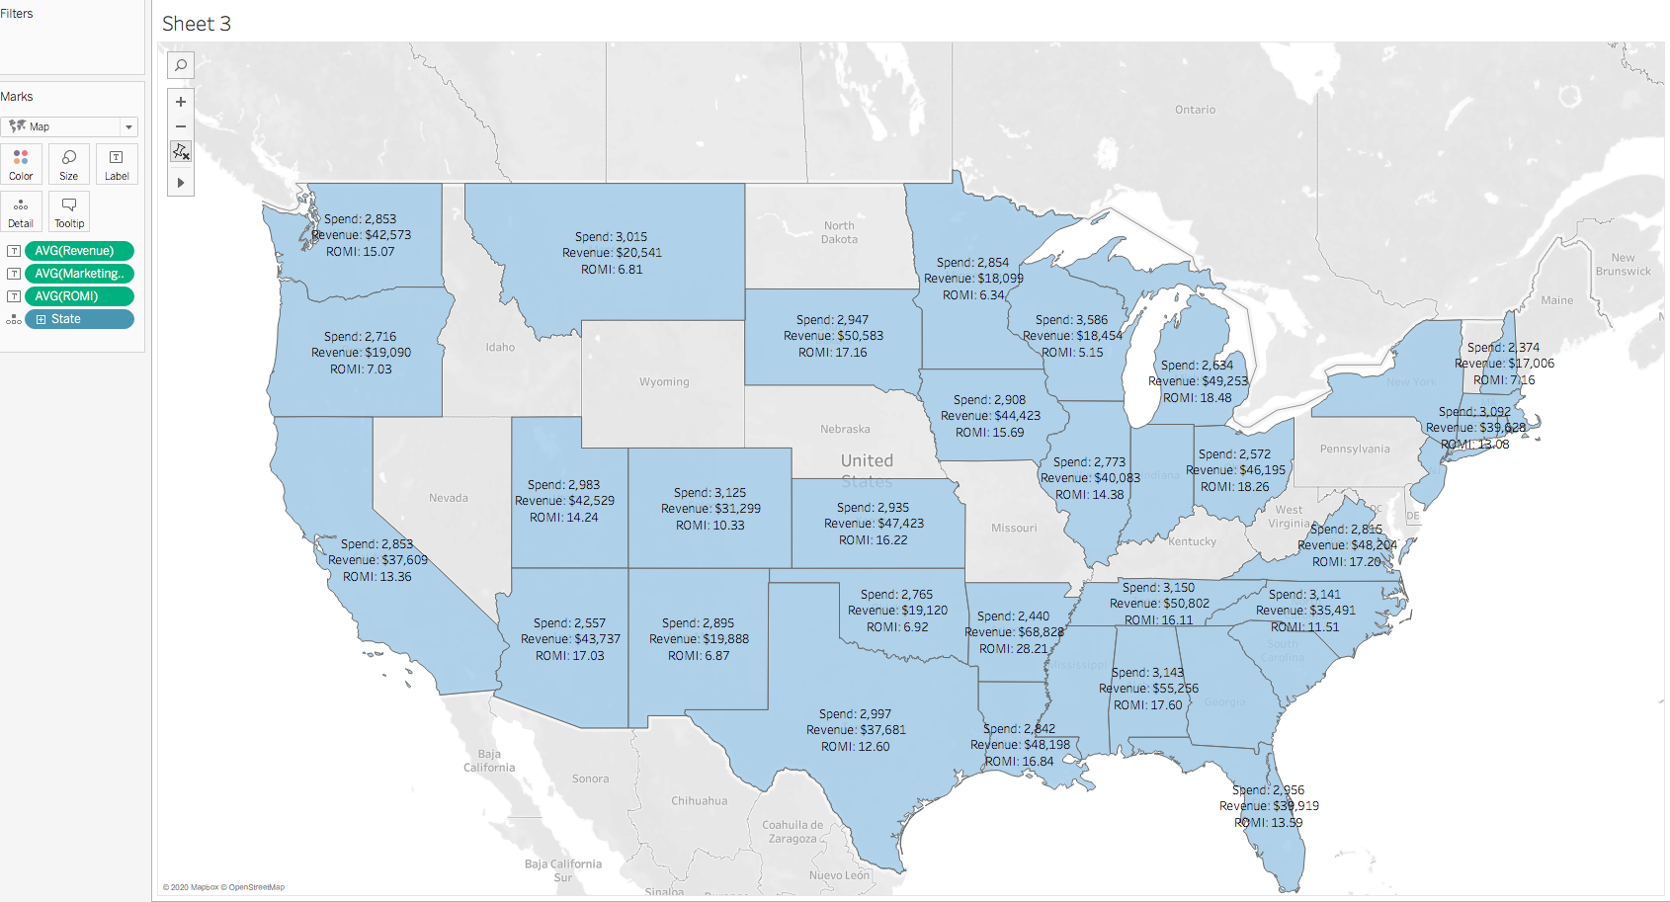

When paint states according to their Avg ROMI per city

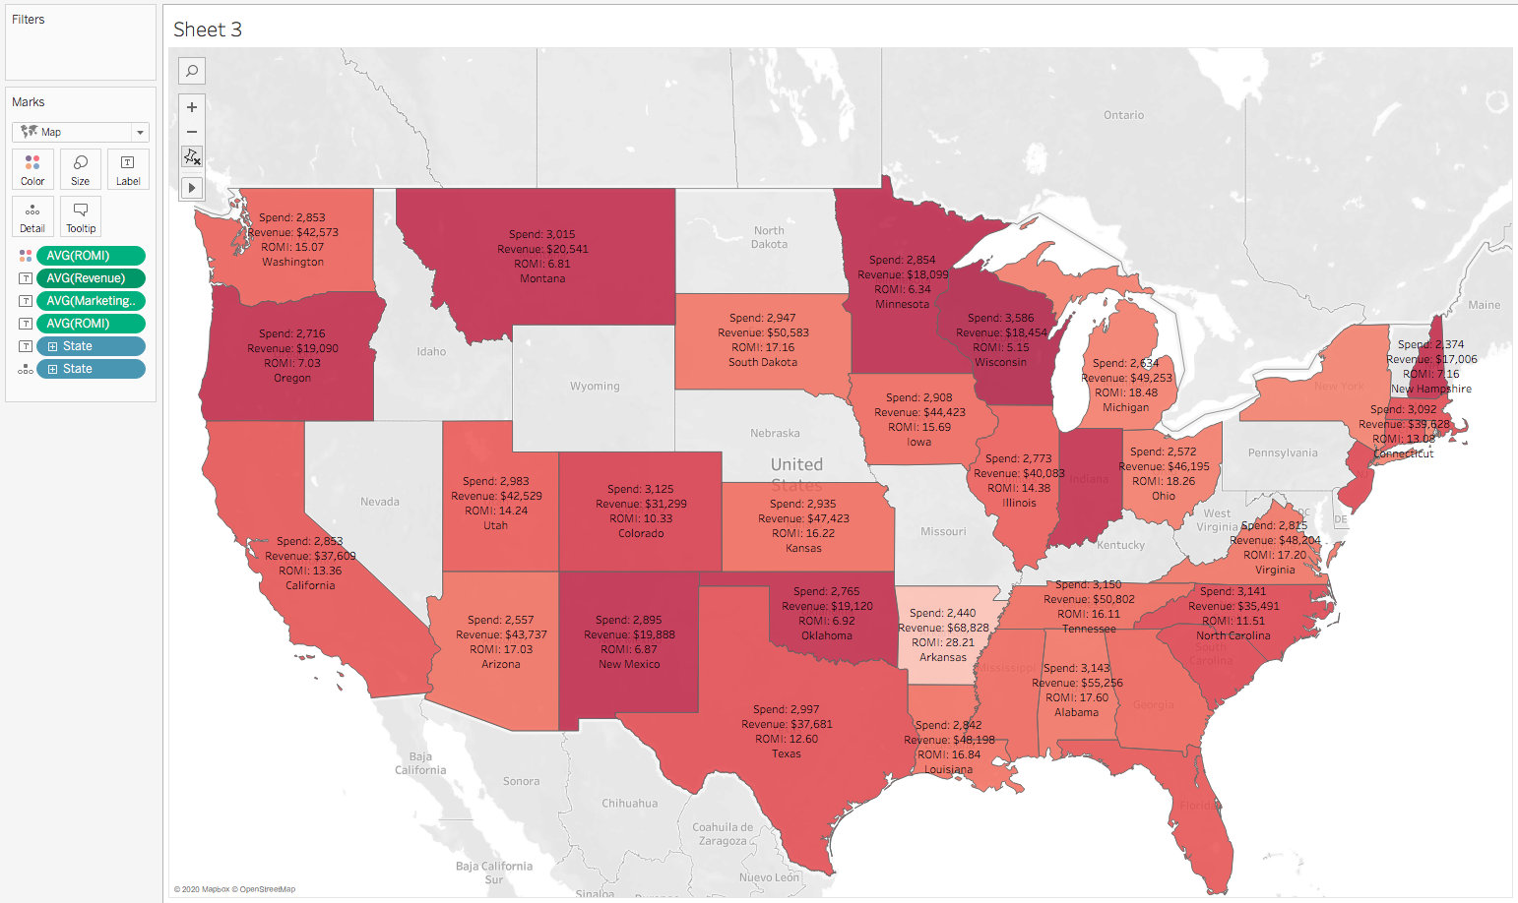

For easier analyzing, we can apply bar chart

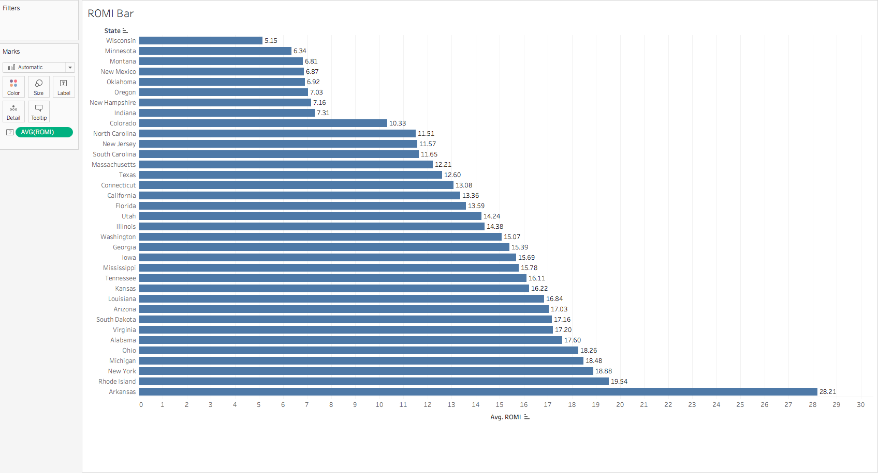

1. Analyzing by Region

Step1: Combine group members according to region

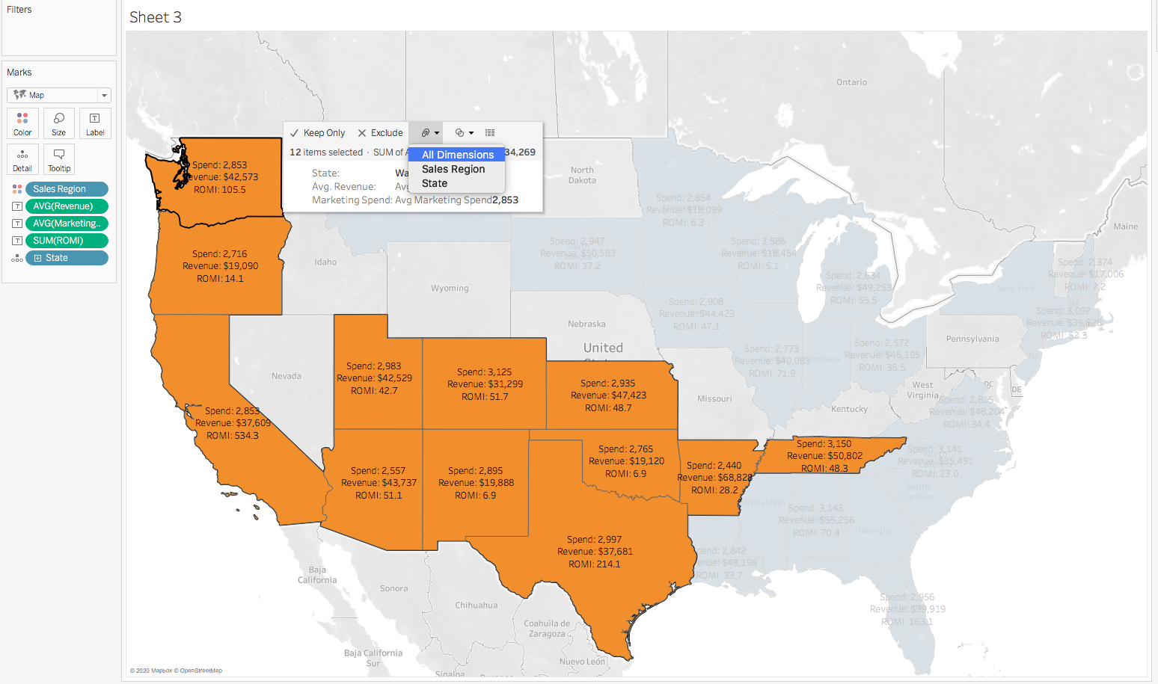

step2: Remove *State* from the map

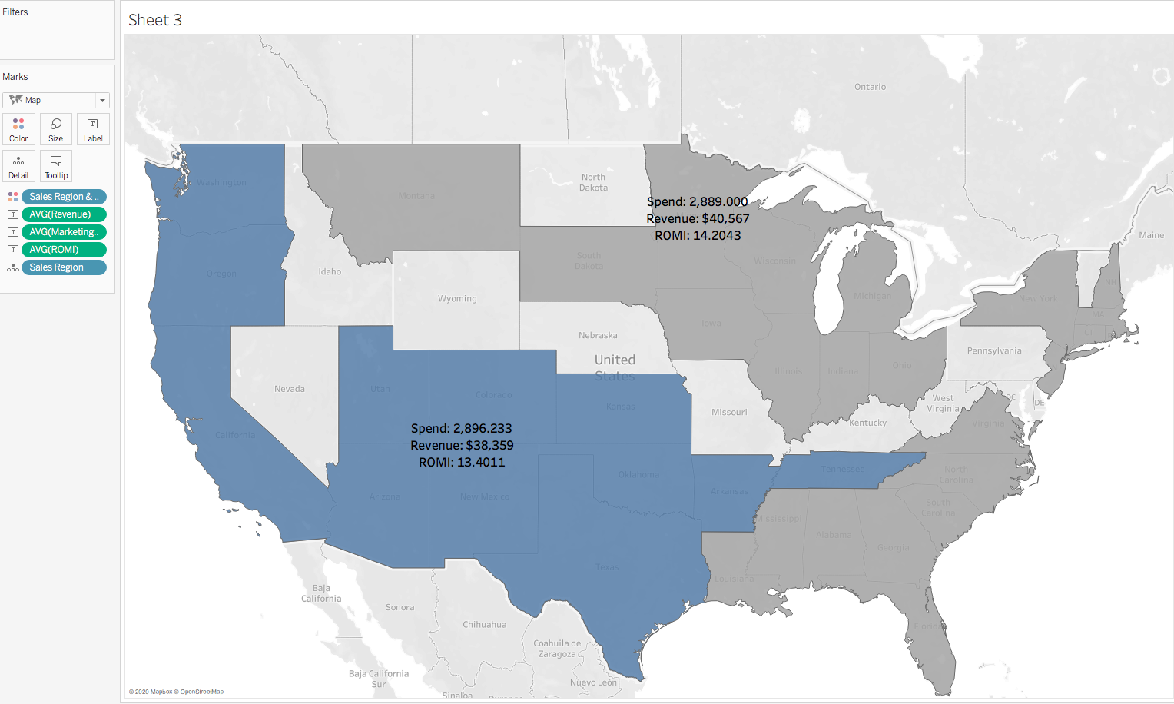

We can see that the Avg ROMI for sales region2 is lower than the region1, which means that sales regions 2 has more potential for investment.